**Comparison of Region Based on Sales**

**Step 1:** Open Tableau 10.x

**Step 2:** On the home page, under Connect, under to a file, click Microsoft Excel.

**Step 3**: Browse and connect to the Sample - Superstore Excel file.

**Step 4:** Drag and drop Data Order tables to the canvas area.

**Step 5:** Create a hierarchy called Location by Dragging country and state, and Rename as location

**Step 6:** Drag Location Hierarchy to Detail Marks Card and Region to Filters, edit the Filter Select the Central region, Select Map in the Marks Card

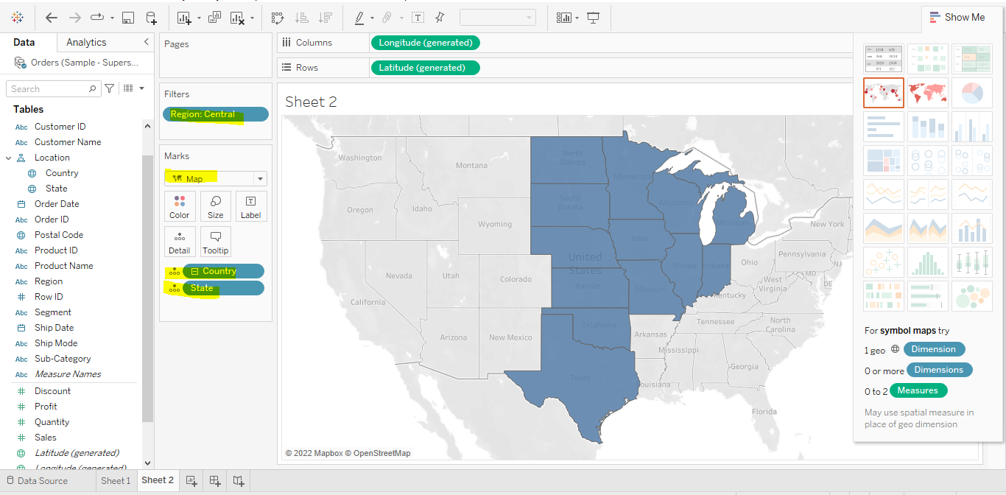

**Step 7:** Right click, Background Layers edit, Style -dark, uncheck the box in Background Map Layers to remove base , land cover lines and click on colour in Marks card to change in the colour of Map, Name the Sheet as Primary Region

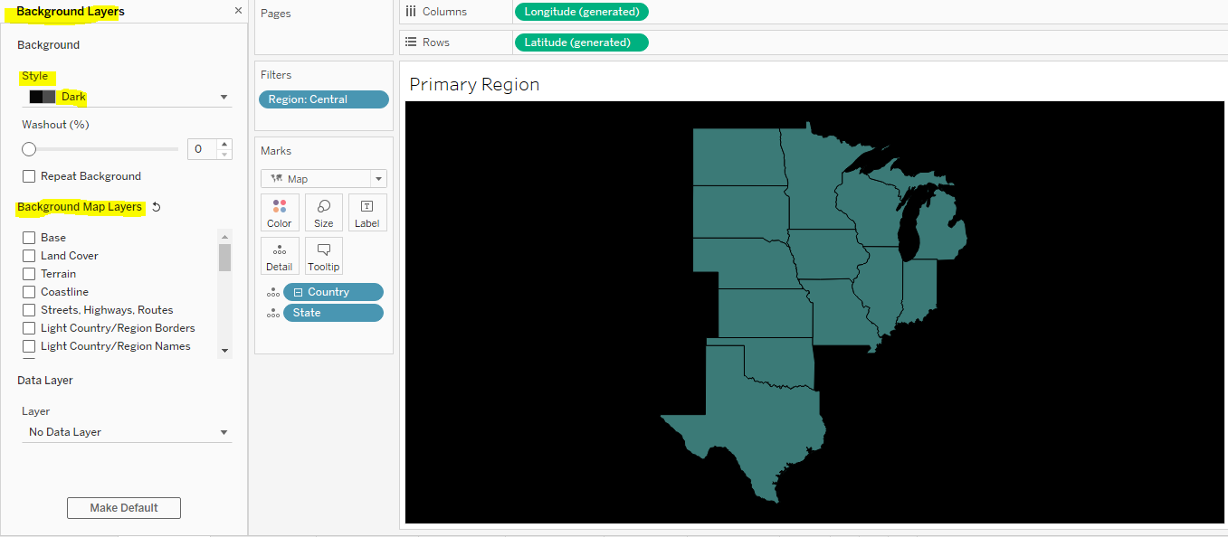

**Step 8:** In the Filter change the Region to East and Repeat the Step 7 , to achieve the Map for East Region as above, Name the Sheet as Secondary Region

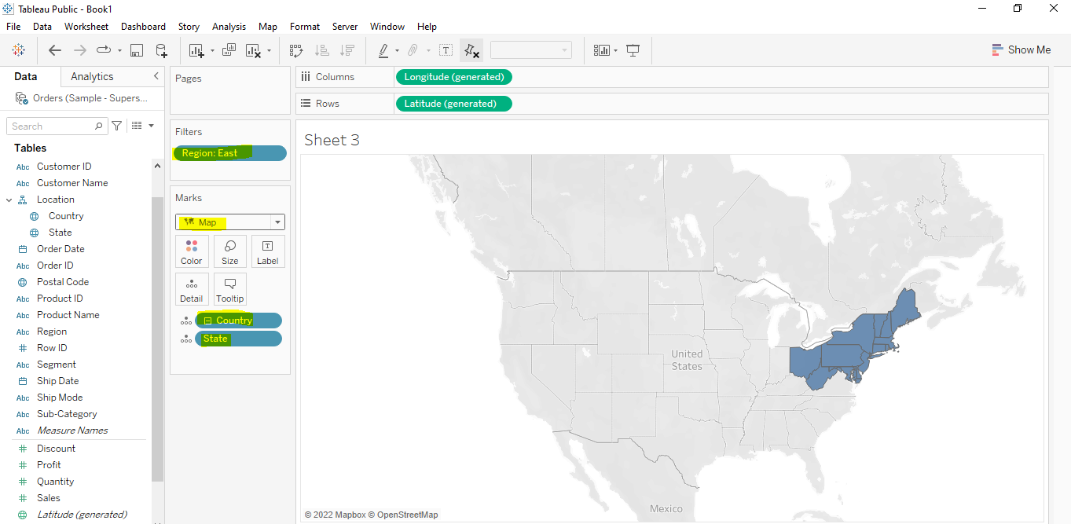

**Step 9:** To create a Sparkline Table, Drag Order date to columns and Sub-Category, Sum(Sales) , Sum(Total Sales), Sum(Minimum Sales) and Sum(Maximum Sales) to Rows and Region Central to Filters Card

**For the columns Sum(Total Sales), Sum(Minimum Sales) and Sum(Maximum Sales) create the Calculated Field using LOD Functions.**

1. For Sum(Total Sales) use the Formula **{ FIXED [Sub-Category], [Region]: SUM([Sales])}**

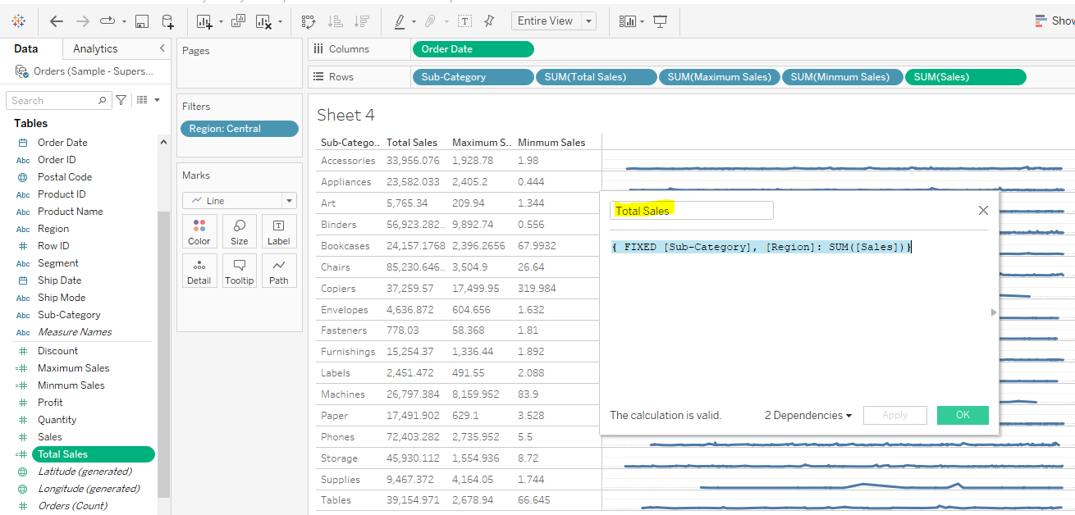

1. For Sum(Maximum Sales) use the Formula { FIXED [Sub-Category], [Region] : MAX([Sales])}

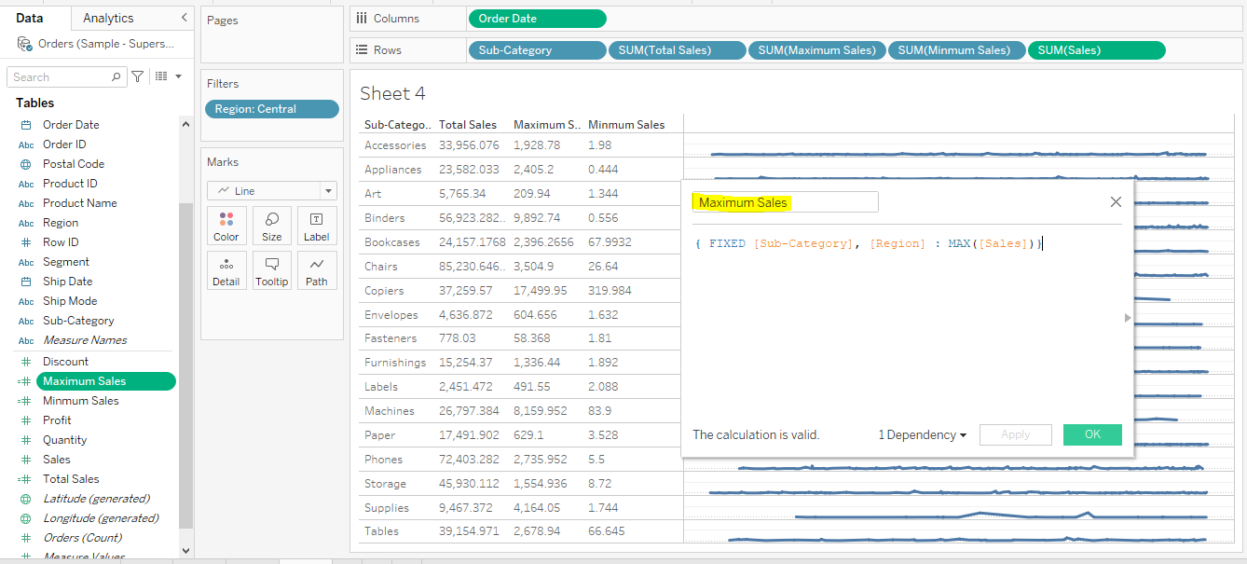

1. For Sum(Minimum Sales) use the Formula { FIXED [Sub-Category], [Region] : MAX([Sales])}

**Step 10:**

1. Right Click on Format and change the background colour in the Worksheet, and change the Font colour according to background colour or requirement

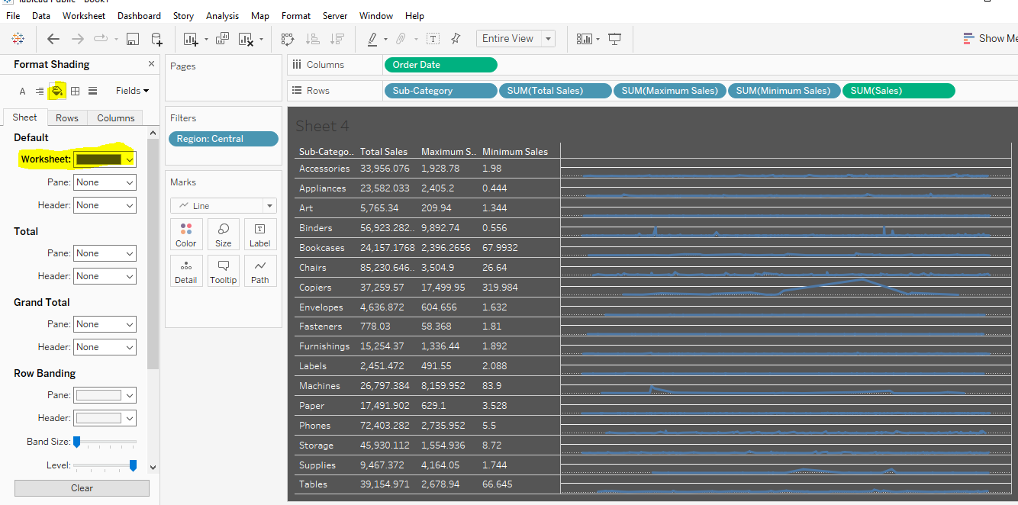

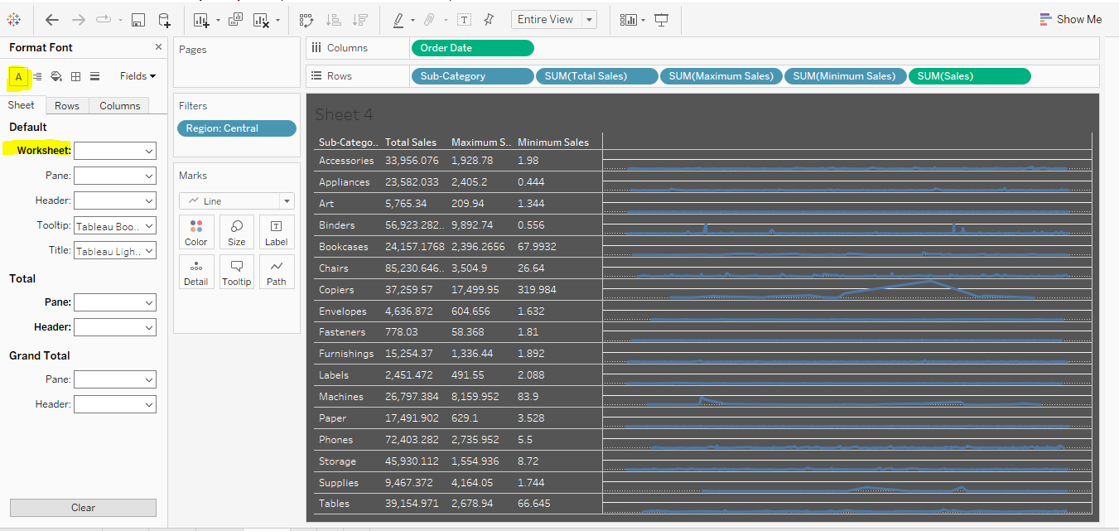

1. Move the Format Lines , in rows change the zero lines, Ref Lines, Drop Lines to None and change the Graph line colour according to the requirement Graphical user interface

   Description automatically generated
2. For the Total Sales, Minimum Sales, Maximum Sales change to number Format to United States Currency

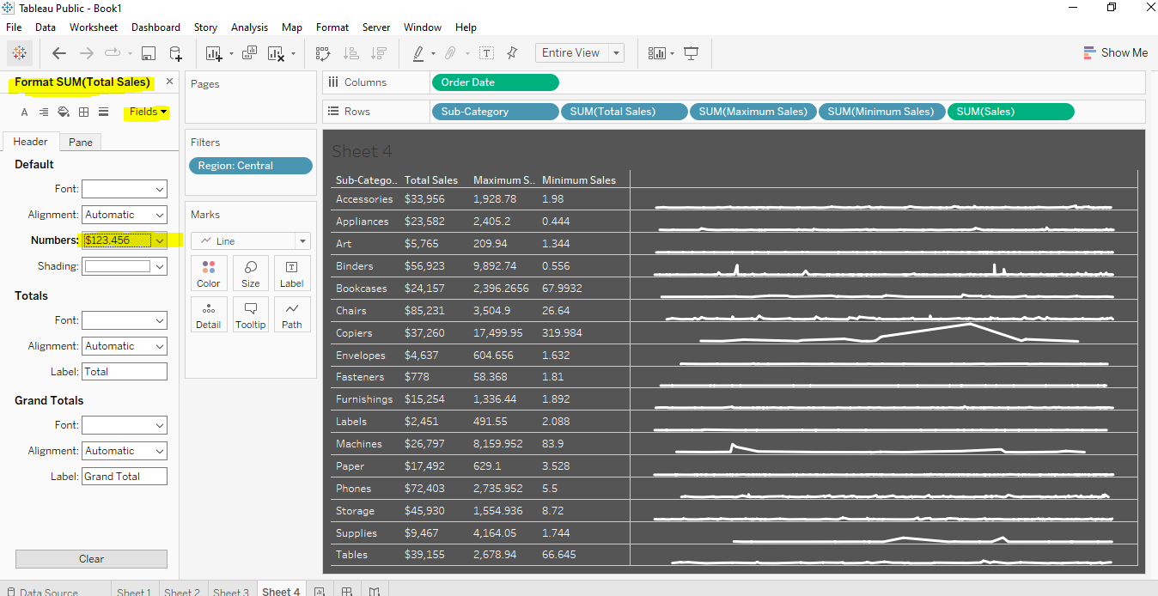

1. For the Format Border of the Table, change to Black border and Header of the table Change the Font colour to Blue colour or as per the Requirement.

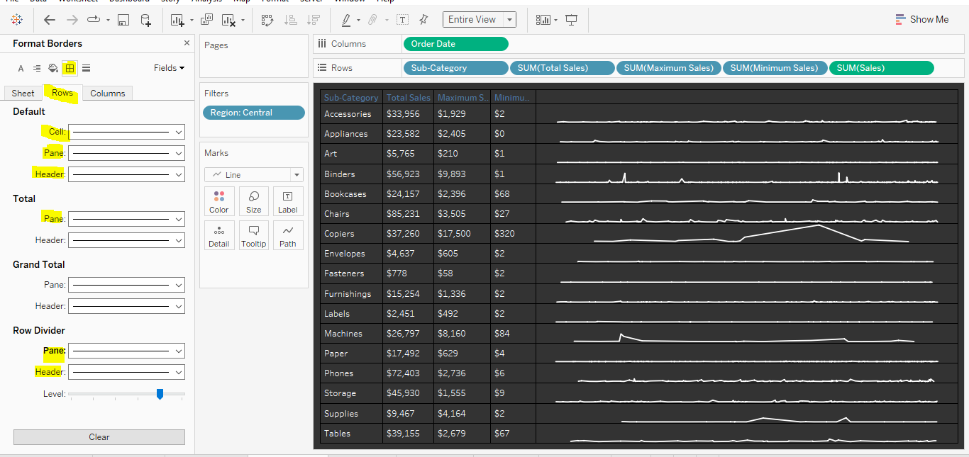

**Step 11:** To create a Sparkline Table, Drag Order date to columns and Sub-Category, Sum(Sales) , Sum(Total Sales), Sum(Minimum Sales) and Sum(Maximum Sales) to Rows and Region East to Filters Card, Repeat Step 10 to achieve the below the result.

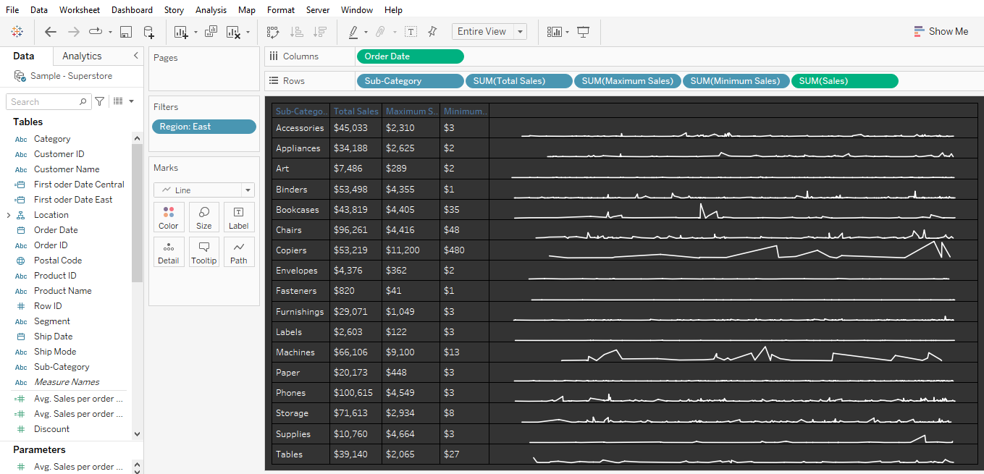

**Step 12:** Drag Sum(Sales) to Column self, Subcategory to Rows self and Region to Filter Card by giving Central in the filter.

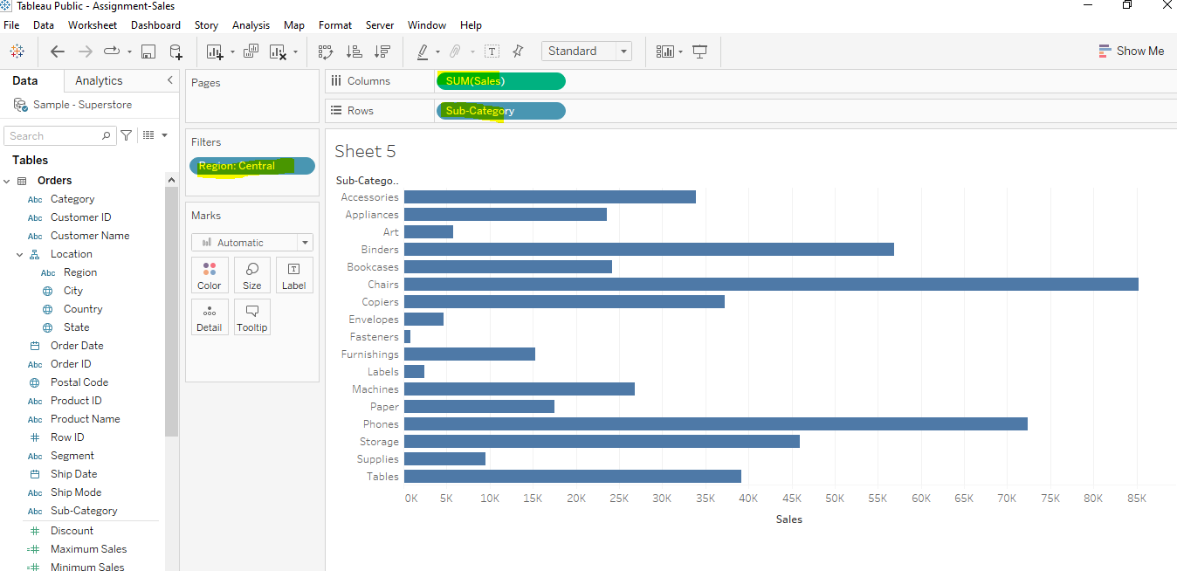

**Step 13:**

**a.** Right click format, Format shading change the Background colour as per the requirement and click and axis uncheck the Show header, headers will be removed from the both the axis

**b.** Then edit the Format lines in both the Subcategory and Sales Field by giving the option none in all the Grid lines, Ref lines, Drop lines, Axis Rulers, So we can get the below the Bar chart.

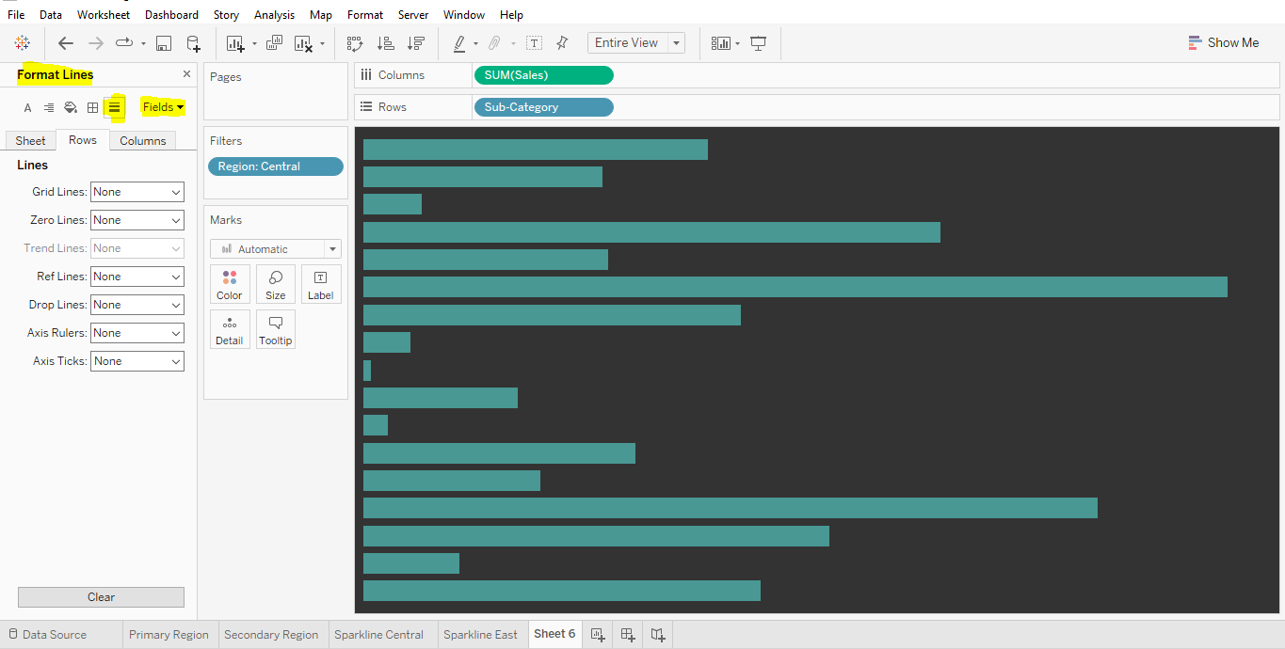

**Step 14:** Drag Sum(Sales) to Column self, Subcategory to Rows self and Region to Filter Card by giving East in the filter. Repeat the Steps 13a and 13b.

**Step 15:** Create the Dashboard Layout as per the requirement to achieve the result. Then drag all the required sheets to the dashboard by aligning properly as required.

**To add the text follow the steps:**

1. For the First order date : Go to Analysis, create Calculated field using formula for both the regions

Central- { FIXED [Region] = "Central": MIN([Order Date])}

East - { FIXED [Region] = "East": MIN([Order Date])}

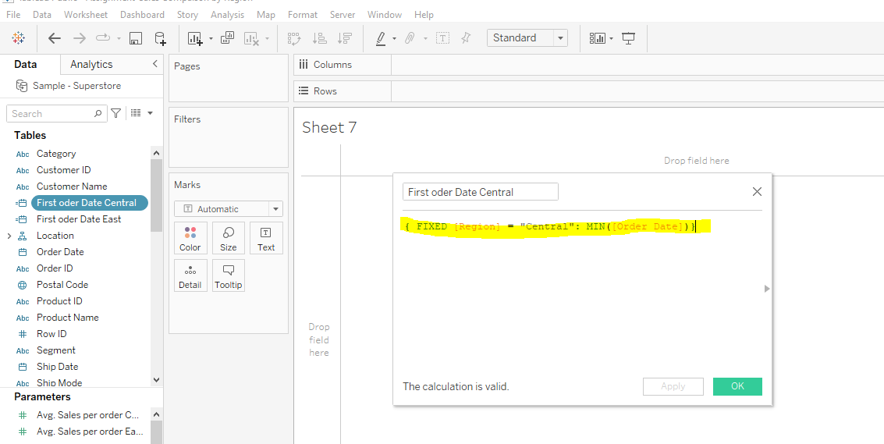

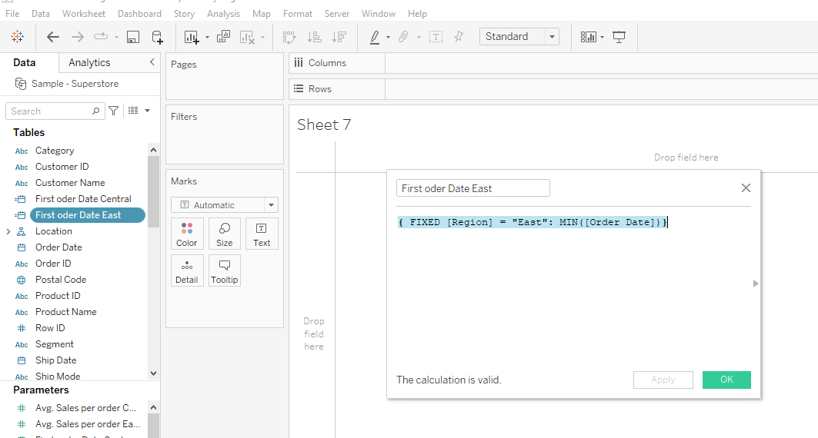

Then create a Parameter for the First order date, Right click -> Create -> Parameter, follow the same for both the Regions and change the display format as per the requirement.

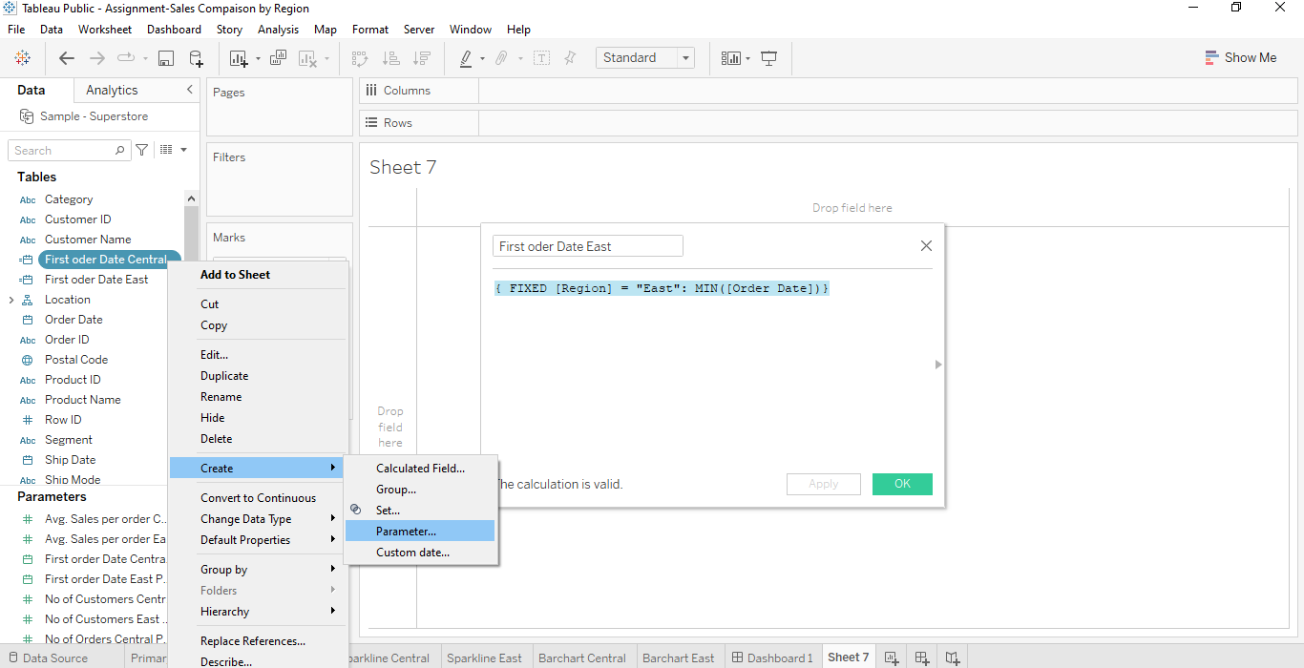

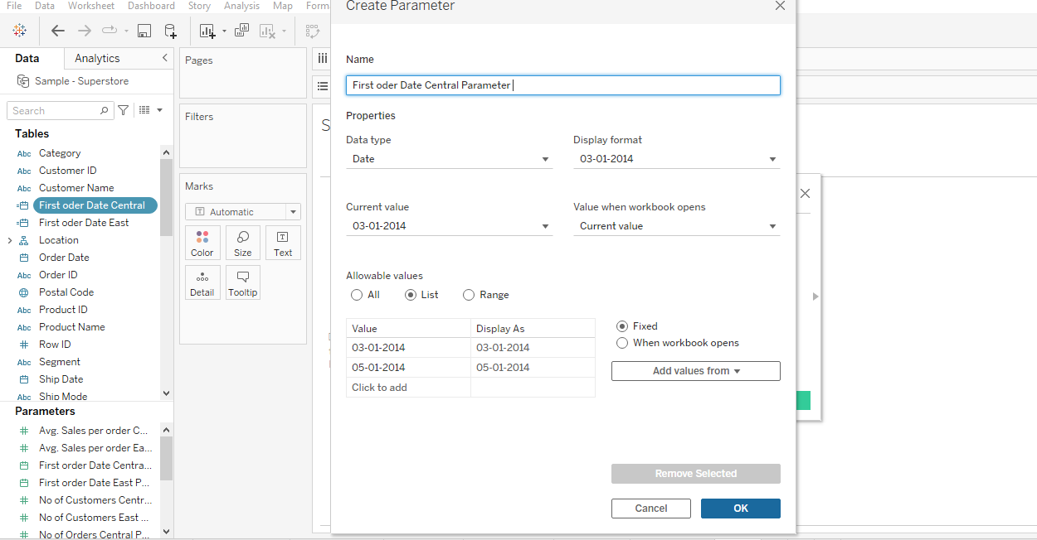

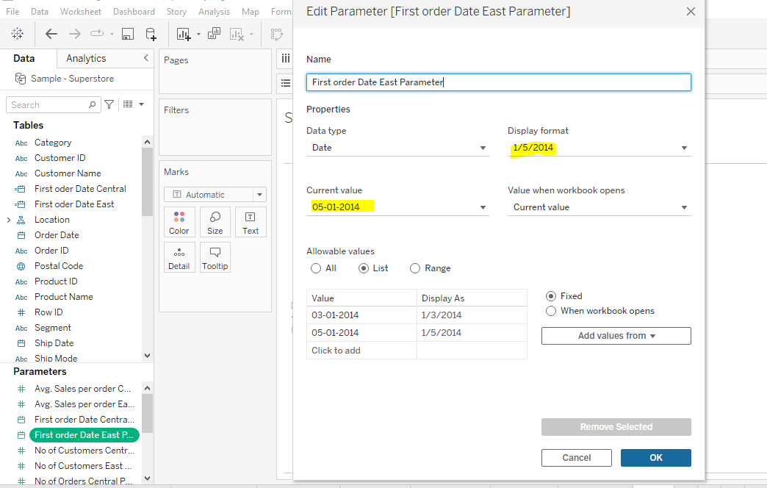

1. Create a Calculated Field for Total Sales using the Formula

Central - { FIXED [Region] = "Central": SUM([Sales])}

East - { FIXED [Region] = "East": SUM([Sales])}

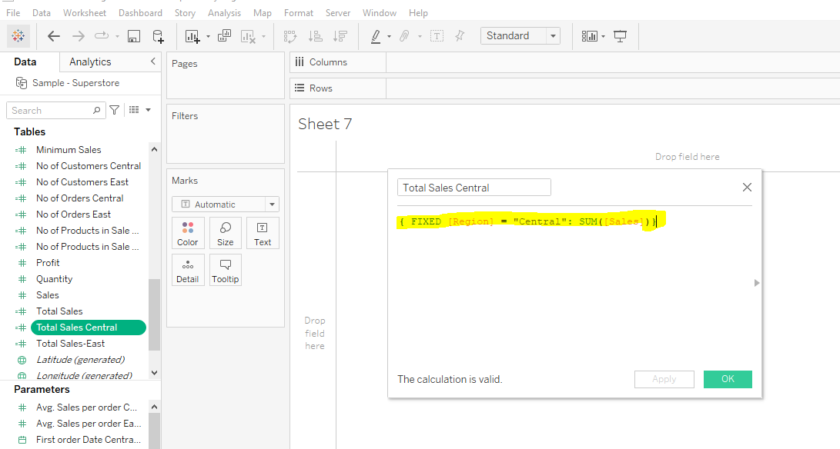

Then create a Parameter for the Total Sales, Right click -> Create -> Parameter, follow the same for both the Regions and change the display format as Currency($).

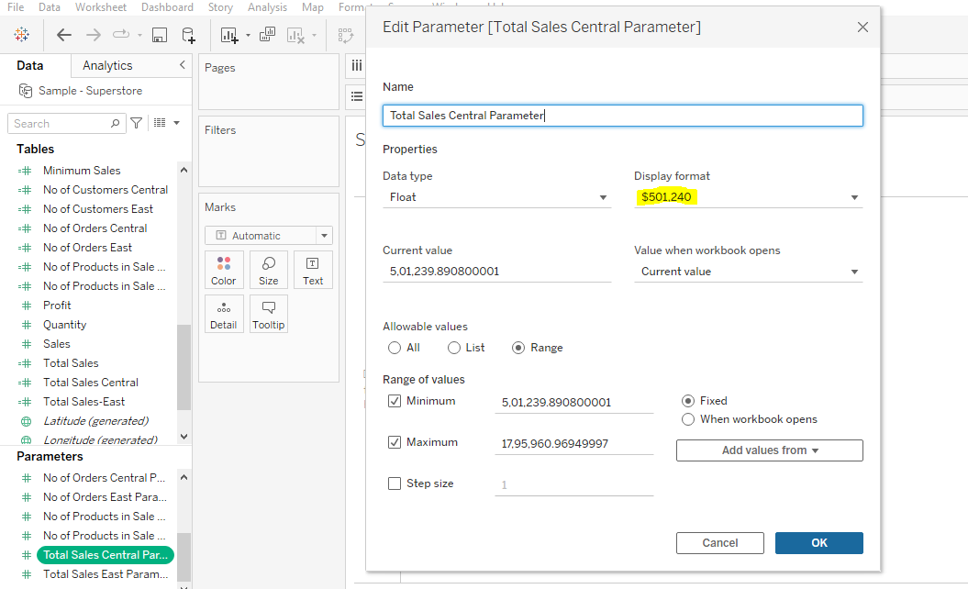

1. Create a Calculated Field for Average Sales per Order using the Formula

Central - { INCLUDE [Region] = "Central" : AVG([Sales]) }

East - { INCLUDE [Region] = "East" : AVG([Sales]) }

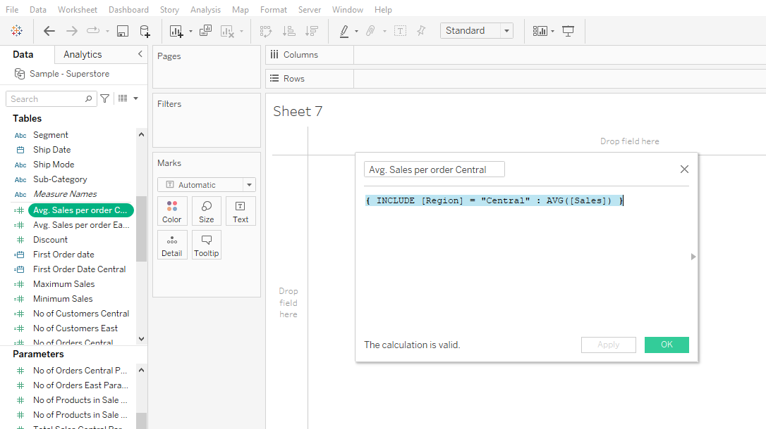

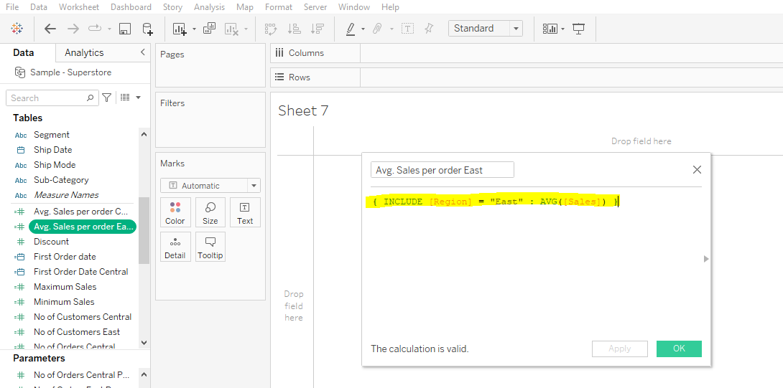

Then create a Parameter for the Average Sales per Order, Right click -> Create -> Parameter, follow the same for both the Regions and change the display format as Currency($).

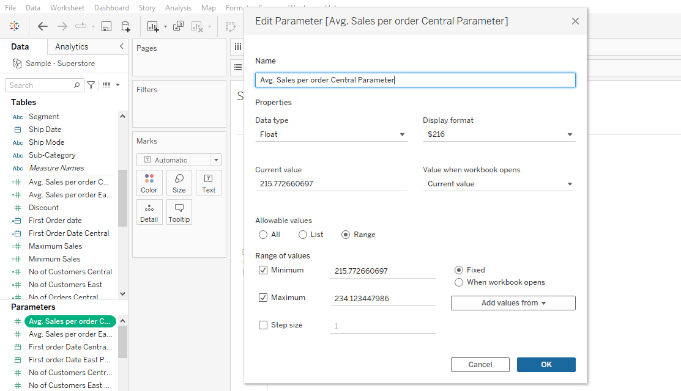

1. Create a Calculated Field for No of Customers, using the Formula

Central - { FIXED [Region] = "Central" : COUNTD([Customer ID])}

East - { FIXED [Region] = "East" : COUNTD([Customer ID])}

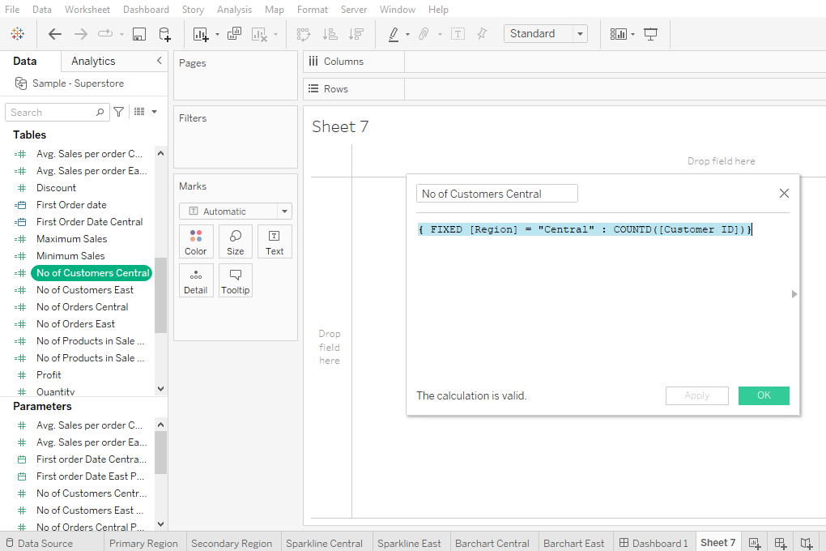

Then create a Parameter for the Average Sales per Order, Right click -> Create -> Parameter, follow the same for both the Regions and change the display format as Currency($).

1. Create a Calculated Field for No of Orders, using the Formula

Central - { FIXED [Region] = "Central" : COUNTD([Customer ID])}

East - { FIXED [Region] = "East" : COUNTD([Customer ID])}

Then create a Parameter for the Average Sales per Order, Right click -> Create -> Parameter, follow the same for both the Regions and change the display as per the requirement

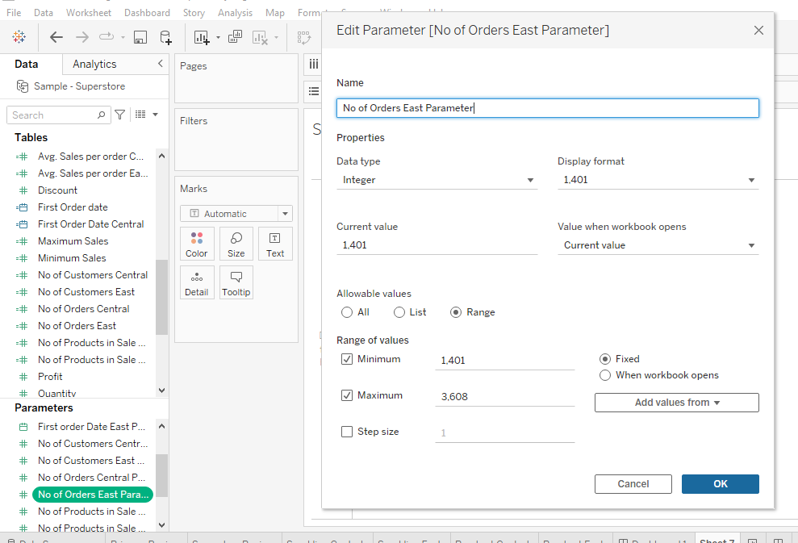

1. Create a Calculated Field for No of Products per Sale, using the Formula

Central - { FIXED [Region] = "Central" : COUNTD([Product ID])}

East - { FIXED [Region] = "East" : COUNTD([Product ID])}

Then create a Parameter for the Average Sales per Order, Right click -> Create -> Parameter, follow the same for both the Regions and change the display as per the requirement.

**Step 16:** To add a text, double click on the required dashboard layout and add the text with the Parameter name, follow the same for both the Central and East Region

Then add the remaining Sheets to the dashboard as per the aligned layout in the dashboard, by giving the heading and other naming for the dashboard to achieve the result.

